Confucius  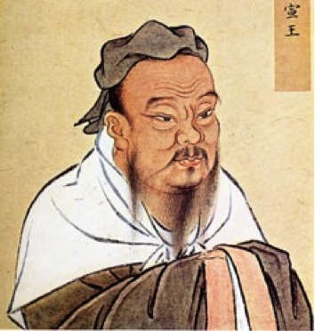 | What did Confucius’ beliefs focus on?  What is one way we know about Confucius and his teachings? | Draw a representation of Confucius’ Code of Behavior and describe how it leads to peace and harmony
Lao-Tze  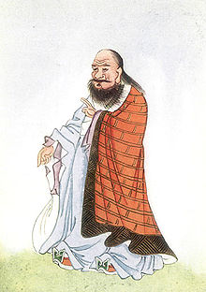 | What are Lao-Tze’s beliefs?  What are Lao-Tze’s views on nature?  What are Lao-Tze’s views on government?  What is one way we know about Lao-Tze and his teachings? | Draw the Yin and Yang and explain its significance
Buddha  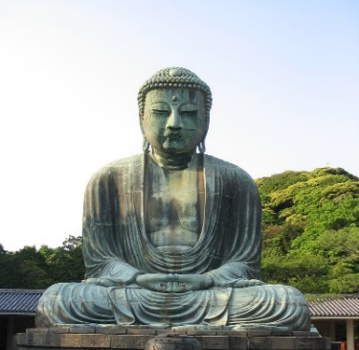 | What does the word Buddha mean?  What are the Four Noble Truths?  What is one way we know about Buddha and his teachings? | Draw the Reincarnation Cycle and describe the Middle Way
Chinese Philosophers

